***FIFTH SEMESTER MPP REPORT***

**PASSWORD BASED CIRCUIT BREAKER**

*Submitted by*

|  |  |  |
| --- | --- | --- |
| **Registration no.** | **Sec-Roll no.** | **Name** |
| 210907154 | A-19 | Tanisha |
| 210907020 | A-5 | Anam |
| 210907236 | A-26 | Ayushi |

**DEPARTMENT OF ELECTRONICS AND COMMUNICATION ENGINEERING**

**MANIPAL INSTITUTE OF TECHNOLOGY**

(A Constituent Institution of Manipal Academy of Higher Education)

MANIPAL – 576104, KARNATAKA, INDIA

**NOV 2023**

**ABSTRACT**

The Password-Based Circuit Breaker project is designed to regulate electrical lines through a password mechanism. In the realm of electrical systems, a circuit breaker serves as a crucial protective device, capable of safeguarding circuits from damage caused by overload or short circuit conditions. The electrical lines transmitting power for commercial, industrial, and residential purposes often carry extremely high voltages and currents, posing potential risks. Measuring the voltage on these transmission lines can be hazardous due to the need for direct contact. Even close proximity to high-voltage lines carries the risk of sparks jumping through the air to nearby objects. Despite these dangers, there are instances during power line installation and repair where contact becomes necessary. The project aims to address these safety concerns and enhance control over electrical lines by incorporating a password-based security feature.

The AC power supply used in the project is converted to required DC using the rectifiers on board the development board. We have four loads that is four light bulbs which are connected to the relay. The relay acts as a switch for the four loads. The IC AT89S52 which is fixed on the development board controls the entire project. The LCD fixed on the breadboard is connected to the development board through jumper wires.

The lack of communication between electric substation staff and linemen has resulted in severe electrical accidents during the repair of electric lines. It is determined that a safety measure to protect the lineman is highly important in this area. To prevent such accidents, a circuit breaker can be configured to allow operation only by an authorized person using a specific password.

The Password-Based Phase Circuit Breaker project is a straightforward solution designed to manage electrical lines using a password for added security. This feature guarantees the safety of the worker, as the electrical line cannot be activated without their permission. The project aims to enhance security in electronic systems, providing an adaptable defence against unauthorized access.

**INDEX**

|  |  |  |  |
| --- | --- | --- | --- |
| Contents | | | Page No |
| Abstract | |  | 1 |
|  | | | |
| **Chapter 1** | | **INTRODUCTION** | 3-4 |
|  | **1.1** | Introduction |  |
|  | **1.2** | Block Diagram |  |
|  | | | |
| **Chapter 2** | | **BACKGROUND THEORY** | 5 |
|  | **2.1** | Theory |  |
|  | | | |
| **Chapter 3** | | **METHODOLOGY** | 6-8 |
|  | **3.1** | Circuit Layout |  |
|  | **3.2** | Component Specification |  |
|  | **3.3** | Methodology |  |
|  | | | |
| **Chapter 4** | | **RESULT ANALYSIS** | 9 |
|  | **4.1** | Result |  |
|  | **4.2** | Significance |  |
|  | | | |
| **Chapter 5** | | **CONCLUSION AND FUTURE SCOPE** | 10 |
|  | **5.1** | Work Conclusion |  |
|  | **5.2** | Future Scope of Work |  |
|  | | | |
| **REFERENCES** | | | 11 |

**CHAPTER 1**

**INTRODUCTION**

1.1 INTRODUCTION

Password Based Circuit Breaker is a project that uses a password to control the electrical lines. The 8051 microcontroller is the circuit's key component. In this project, the password is entered using a 4x4 keypad. The entered password and the predefined password are compared. The related electrical line is turned ON or OFF based on whether the password entered is correct or not. In this project, each electrical line has its own password. The load (light bulbs) indicates when the line (circuit breaker) is activated or deactivated.

Password-based circuit breakers are useful in a variety of applications where secure access control is critical. The integration of password authentication with circuit-breaking mechanisms is commonly employed in electronic systems, IoT devices, and industrial control systems. The primary purpose is to improve security by preventing unauthorized access and protecting sensitive information or critical processes.

The number of electrical accidents affecting linemen during line repairs is rising these days. It arises due to miscommunication between the electrician and the electrical sub-station. This initiative offers a resolution to the problem, aiming to ensure the safety of linemen in response to the identified issue.

The concept is designed to necessitate the entry of a password by maintenance staff or workers for the activation or deactivation of electrical lines. In situations where there is a malfunction or the need for repair, the supply to the affected line can be easily halted by entering the password. This functionality simplifies the process of fixing the line. Once the repair is complete, the supply to the electrical line can be reinstated by entering the password once again.

In summary, based on the provided information, it can be concluded that this approach provides a means to ensure exclusive control of the system by the lineman, minimizing the risk of external interference. This setup enables linemen to efficiently operate from a central location rather than having to attend to each individual circuit breaker source

1.2 BLOCK DIAGRAM

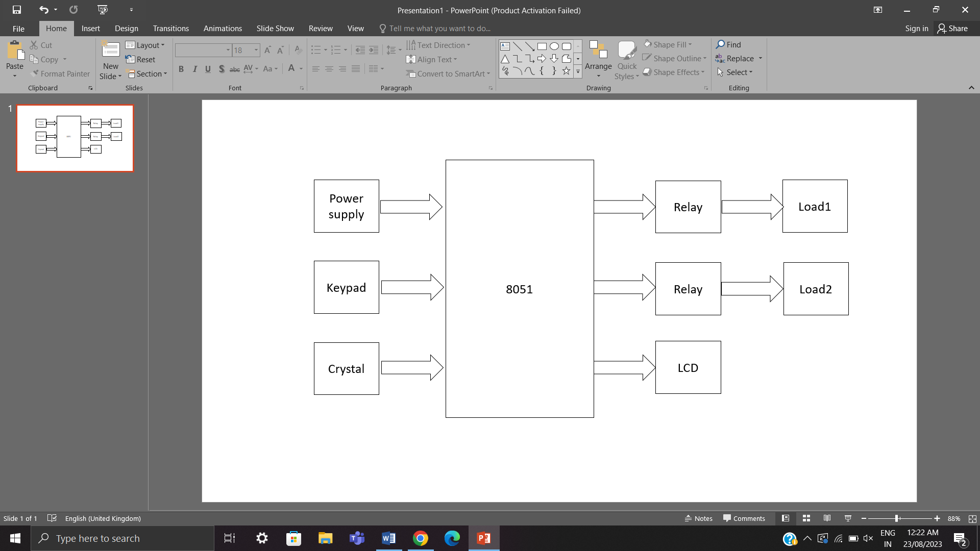

The 8051 microcontroller is the circuit's key component. A small keypad with 16 keys which is interfaced with a microcontroller is used to enter the password. This keypad has a 4X4 matrix form, and the data it generates is stored in RAM. It depends upon the controller programme that is prepared, and if the data it produces matches the predefined programme, the corresponding relay will be activated automatically.

To enhance security, the information entered on the keypad will be masked on the LCD display as asterisks ('*'). If the entered data is accurate, the LCD will indicate that the respective electrical line has been deactivated. To reactivate the line, the password must be entered once more. This additional layer of password protection contributes to the overall security of the system.

The password-based circuit breaker project offers several notable advantages. Firstly, it contributes to the avoidance of electrical accidents, ensuring the safety of line workers who may be exposed to potential hazards. Secondly, the implementation of a circuit-breaking mechanism enhances the overall safety of line workers by preventing unauthorized access and potential misuse. Additionally, the project stands out for its simplicity and ease of use, designed to be accessible to users and administrators alike. Lastly, its applicability in public areas underscores its versatility, making it particularly useful for systems where controlled access is essential for security.

**CHAPTER 2**

**BACKGROUND THEORY**

2.1 THEORY

The background theory of a password-based circuit breaker revolves around the fusion of access control and circuit protection mechanisms. Access control, utilizing passwords as a fundamental authentication tool, is enhanced by integrating a microcontroller, such as the 8051, to actively manage and respond to security events.

The microcontroller serves as the main processor for the system; it manages password inputs, keeps an eye on unauthorised entry attempts, and initiates circuit-breaking operations when it detects it. This dynamic response adds a layer of adaptability, allowing for the customization of security parameters and responses based on specific application requirements.

The theory emphasizes secure password management, incorporating principles of strong password generation and protection against brute force attacks. By combining these elements, the password-based circuit breaker offers a flexible and proactive security solution that mitigates unauthorized access risks in electronic systems.

**CHAPTER 3**

**METHODOLOGY**

2.1 CIRCUIT LAYOUT

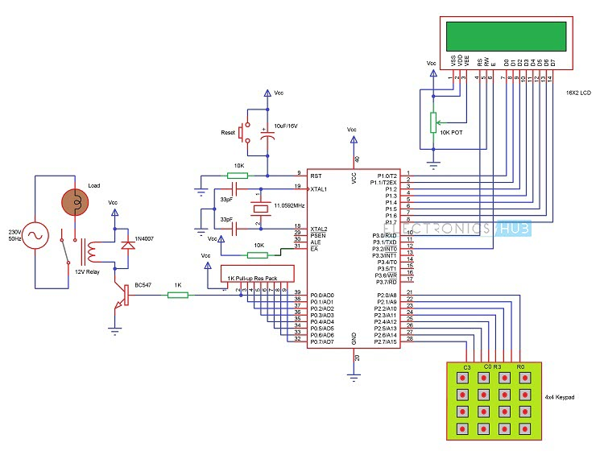

The LCD fixed on the breadboard is connected to the P1.0 to P1.7 pins of the development board. The RS and E pin of the LCD is connected to the P3.0 and P3.2 pins of the development board. The 4x4 matrix keypad is connected to the P2.0 to P2.7 pins. The bulbs are screwed to the relay module.

2.2 COMPONENT SPECIFICATIONS

Microcontroller (AT89S52): It is a powerful micro controller, which provides a highly flexible and cost-effective solution to our project.

* Low-power, high-performance CMOS 8-bit microcontroller.
* In-system programmable Flash memory (8K Bytes).
* Endurance: 1000 Write/Erase Cycles.
* Operating Range: 4.0V to 5.5V.
* Fully Static Operation: 0 Hz to 33 MHz.
* Internal RAM: 256K.
* Programmable I/O Lines: 32.

16*2 LCD: An LCD (Liquid Crystal Display) screen, functioning as an electronic display module, is widely applied, with the 16x2 LCD display being particularly basic and commonly utilized in various devices and circuits.

* Utilizes liquid crystal technology for display.
* Displays the password entered to control the ON/OFF state of circuit breakers.
* Character LCD with a 16*2 format.
* Power Supply: +5V.
* Operates with a 1/16 duty cycle.

4*4 Matrix Keypad: A matrix or numeric keypad is a set of buttons arranged in a block which usually bear digits, symbols and alphabetical letters interfaced with the development board. In the case of 4*4 matrix keypad, it consists of the numbers from 0 to 9, letters from A-D, ‘*’ and ‘#’ which make up a total of 16 buttons.

* Maximum Rating: 24 VDC, 30 mA.
* Interface: 8-pin access to 4x4 matrix.
* Operating temperature: 32 to 122 °F (0 to 50°C)
* Dimensions: Keypad, 2.7 x 3.0 in (6.9 x 7.6 cm)

Development Board: Use of the development board reduces the need for extra hardware circuitry such as Transformer, rectifier and capacitors. It is easy to use and also reduces the problem of loose connections.

* On-board bridge rectifier enables the 8051 board to accept both AC and DC input voltages.
* ZIF (Zero Insertion Force) socket for easy use.
* 5mm Power Plug-in DC Jack.
* Power ON-OFF switch.
* Power indication with a RED LED.
* Quartz crystal with a frequency of 11.0592MHz.
* Reset button for system restart

Relay: We have used a 4 channel Isolated 12V relay module. This acts as a switch for the loads.

* Four Channels in a single module
* 12V operating Voltage
* Max output of AC250V 10A and DC5V 10A

Bulbs: We have used four bulbs as loads. They are screwed to the relay module.

* 10 watt bulb
* 230V
* Soft White colour

2.3 METHODOLGY

The project utilizes an AC power supply, which is transformed into the required DC power using rectifiers integrated into the development board. The system comprises four loads represented by light bulbs, connected to a relay functioning as a switch. The IC AT89S52, mounted on the development board, serves as the central controller for the entire project. An LCD, positioned on the breadboard, is linked to the development board via jumper wires. The functionality of the circuit breaker, operated through a password, is achieved by writing a program in Keil software. This program is then converted into a hex file, which is subsequently loaded onto the controller using flash magic.

Ensuring safety during connections is crucial, particularly to avoid any common links between AC and DC supplies. It's imperative to exercise caution with relay output pins as they receive 230V. The LCD initiates by displaying "enter password." After entering the password through the keypad, the LCD exhibits '*' for each digit. If the entered password is accurate, the circuit breaker's status changes, and the updated status is displayed on the LCD screen. Conversely, if the password is incorrect, the LCD indicates "access denied." This design provides a secure and user-friendly method for controlling the circuit breaker's state through password authentication.

**CHAPTER 3**

**RESULT ANALYSIS**

3.1 RESULT

When the correct password from the code is entered the corresponding channel of the relay module is switched on and the bulb connected to the relay is switched on. When the same password is entered again the corresponding bulb is switched off.

3.2 SIGNIFICANCE OF THE RESULT

When lineman gets the information that the line is faulty, he enters the password and disconnects that particular line and repairs it comfortably without any worry of danger. After servicing, he can restore the line himself.

**CHAPTER 4**

**CONCLUSION AND FUTURE SCOPE**

4.1 CONSLUSION

Password based circuit breaker is operated only by using a password. In this system we used 8051 microcontroller, relay module, LCD display, keypad and bulbs as load. This is an easy method to solve the life of a lineman as it only involves entering a password to turn the load on or off. This method is more accurate and better for the lineman's safety. The project aims to enhance security in electronic systems, providing an adaptable defence against unauthorized access.

4.2 FUTURE SCOPE

In the future, password-based circuit breakers are likely to integrate advanced technologies such as biometrics, artificial intelligence, and block chain for enhanced security. They may play a crucial role in securing IoT devices and align with zero-trust security frameworks.

A GSM module can be integrated with the system so that when a line stops working, the gsm module will send an SMS to the workstation and a quicker response can be given for the repairing process.

**REFERENCES**

<https://www.electronicshub.org/password-based-circuit-breaker/>

<https://www.ijert.org/research/password-based-circuit-breaker-control-to-ensure-electric-line-mans-safety-and-load-sharing>

<https://arvingroup.in/password-based-circuit-breaker/>